

**Terra Industrial New Zealand Ltd**

PO Box 16 168

16 Branston Street, Hornby

Christchurch 8441, New Zealand

03 983 2333 tel

03 983 5715 fax

www.TerraCat.co.nz



**CUSTOMER DATA STANDARDS**

Sales Person

Contacts

**Terra Industrial New Zealand Ltd**

PO Box 16 168

16 Branston Street, Hornby

Christchurch 8441, New Zealand

03 983 2333 tel

03 983 5715 fax

www.TerraCat.co.nz

29 JUNE 2020

# Customer Data Standards

TC-CDS-SalesPerson-1.1

## Sales Person

Data owners:  
David Hotham

For:

Marketing team, Sales Manager

Contents

Customer Data Standards 2

Sales Person 2

Document History 4

Document information 4

Document amendment history 4

Business Rules: Sales Person 5

Navigation 7

Sales order defaults 8

## Document History

### Document information

|  |  |
| --- | --- |
| Current Version | 1.1 |
| Release Date | 19 June 2020 |
| Document Owner | Jessica Macfarlane |

### Document amendment history

|  |  |  |  |
| --- | --- | --- | --- |
| Version | First Release | Sections(a) Amended | Summary of Amendment |
|  |  |  |  |
|  |  |  |  |
|  |  |  |  |
|  |  |  |  |
|  |  |  |  |

|  |  |  |  |
| --- | --- | --- | --- |
|  |  |  |  |
|  |  |  |  |
|  |  |  |  |
|  |  |  |  |
|  |  |  |  |
|  |  |  |  |

## Business Rules: Sales Person

|  |  |
| --- | --- |
| Rule 1 | The Business ERP (NAXT) must be the "One Source of Truth" for Customer Sales Reps across the Business |
| Rule 2 | Any Business application containing Customer Sales Reps must be consistent with NAXT, primarily SalesLink (CRM) |
| Rule 3 | All required inputs must be made mandatory in NAXT and must be complete and valid |
| Rule 4 | Every Customer Sales Rep must have a unique NAXT Salesman code with the following convention in accordance with their area of responsibility:  Division + Location + number sequence  e.g. EEQROT01 (EEQ Equipment + ROT Rotorua + 01) |
| Rule 5 | A running sequence of Sales Rep codes must be centrally maintained by Marketing Gatekeepers |
| Rule 6 | All requests for Sales Rep setup must be received via the established Business process |
| Rule 7 | Only nominated Marketing Gatekeepers must have access to create Sales Reps in NAXT |
| Rule 8 | Line Managers must ensure that every Customer account has a Sales Rep assigned in accordance with their respective Customer coverage area |
| Rule 9 | Customer accounts must typically be assigned as follows:  1 x ISR or PSSR against EPT division  1 x EEQ against EEQ division  1 x POWER against EPS division |
| Rule 10 | Any Sales Rep no longer relevant against the assigned account must be removed and replaced accordingly |
| Rule 11 | Sales Reps codes must stay with the established Customer regions rather than with the Sales Reps |
| Rule 12 | NAXT user access levels and system functionality must be in accordance with established Business rules |
| Rule 13 | Data Owners must ensure Business rules and Data standards developed are adhered to and ongoing data errors identified are actioned in line with established Business procedures |
| Rule 14 | Nominated SMEs must ensure Business rules and Data standards developed are feasible across all impacted Business areas and work with Data Owners on change management |
| Rule 15 | Any changes and exceptions to these rules must be approved by the Data Standards Owner |

## Navigation

GGNZ > Sales and Marketing > Common > Prospects > All prospects

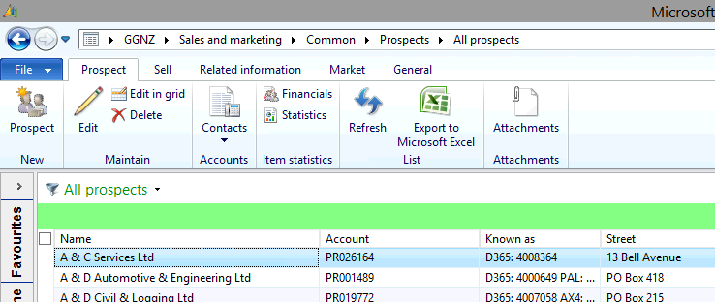

### Sales order defaults

|  |  |  |
| --- | --- | --- |
| **Field** | **Mandatory** | **Data Standard** |
| Salesman code | Y | Running sequence - Unique identification |
| Division | Y | Rep's primary division |
| Area of Business | N |  |
| Salesperson Type | Y | In accordance with area of responsibility: ISR - Inside Sales Rep, CSAM, TAM. |
| OLGA Type | Y | Aligned to Salesperson Type |
| Worker | Y | Dropdown selection from Employee Address book |
| Name | Y | Auto populated from Worker selection |
| Telephone | N | Auto populated from Worker selection |
| E-mail | N | Auto populated from Worker selection |
| PARS | N | Default: 0 |

